AWS

Amazon Web Services, Inc. (AWS) is a subsidiary of Amazon that provides on-demand cloud computing platforms and APIs to individuals, companies, and governments, on a metered, pay-as-you-go basis.

Oftentimes, clients will use this in combination with autoscaling. These cloud computing web services provide various services related to networking, compute, storage, middleware, IoT and other processing capacity, as well as software tools via AWS server farms.

One of the foundational services is Amazon Elastic Compute Cloud (EC2), which allows users to have at their disposal a virtual cluster of computers, with extremely high availability, which can be interacted with over the internet via REST APIs, a CLI or the AWS console. AWS's virtual computers emulate most of the attributes of a real computer, including hardware central processing units (CPUs) and graphics processing units (GPUs) for processing; local/RAM memory; hard-disk/SSD storage; a choice of operating systems; networking; and pre-loaded application software such as web servers, databases, and customer relationship management (CRM).

EC2
Amazon Elastic Compute Cloud is a part of Amazon.com's cloud-computing platform, Amazon Web Services, that allows users to rent virtual computers on which to run their own computer applications.

- How to create EC2 instance?
- How to connect with EC2 instance?
- How to add user data (commands/scripts in EC2 instance)?
#!/bin/bash
apt-get update -y
apt-get install apache2 -y
echo "Welcome to this test EC2 website" > /var/www/html/index.html
service apache2 start

S3 Bucket

- How to create S3 bucket and upload data on it?
- What is versioning in S3 bucket and how to use it?
- How to make S3 bucket public?
- How to deploy a static website on S3 bucket and set error page for anything.

IAM
https://docs.aws.amazon.com/IAM/latest/UserGuide/introduction.html
https://docs.aws.amazon.com/powershell/latest/userguide/pstools-appendix-sign-up.html

- What is IAM?
- How to create a user in AWS?
- How to generate keys for a user in AWS? (For CLI)
- (AdministratorAccess)
- How to Configure Terraform Environment Variables for AWS Access Keys?
- Generate the AWS credentials for CLI user
- Go on google → search for AWS provider (https://registry.terraform.io/providers/hashicorp/aws/latest/docs) → here we can see different ways to auth terraform to AWS → here we will select Environment Variables approach →
export AWS_ACCESS_KEY_ID=""
export AWS_SECRET_ACCESS_KEY=""
export AWS_REGION=""

Terraform

- Cloud Service Provider - AWS
- Visual Studio Code
- Terraform (Install)
https://developer.hashicorp.com/terraform/downloads?product_intent=terraform
- https://github.com/yogeshgupta0246/website-clothesfashion

- Terraform is a declarative

- Create a folder in VSC
- Create a file in folder → main.tf
provider "aws" {
region = "us-east-1"
}
- Now execute the main.tf file
$ terraform init
- Commands:-

- $ brew install terraform (for mac OS)
- $ terraform --version
- $ terraform version
- $ terraform init
- $ export AWS_ACCESS_KEY_ID=*******
- $ export AWS_SECRET_ACCESS_KEY=*********
- $ export AWS_REGION=*********

- Creating AWS S3 Buckets with Terraform:-
- Already configure access keys inside the terraform
- Create a main.tf file in VSC and define provider
- then define the plan & execution
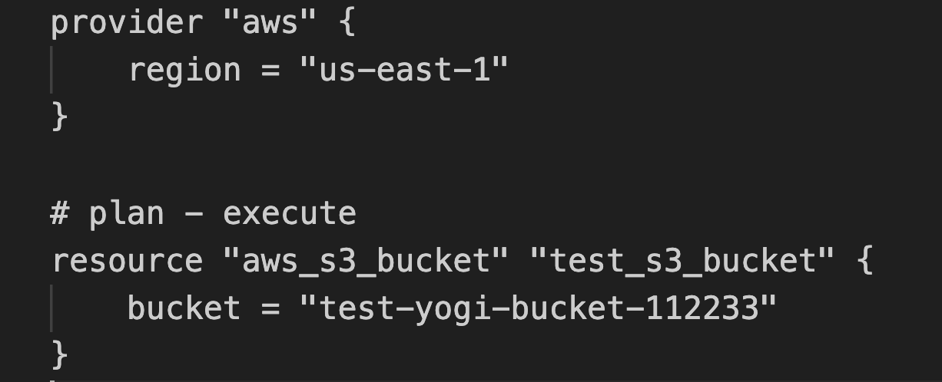
$ terraform plan

$ terraform apply

Note: If I will re-execute this terraform apply command so nothing will happen and the question is how terraform knows that nothing has changed.
There are 3 states in Terraform:
- Desired: What we specify in terraform script is called desired state. This I want in cloud.
E.g I want s3 bucket,
I want EC2
- Known: It is the result of the previous execution which is present in .tfstate file
- Actual: What is actually present in Cloud (AWS)
- Now let's say I want this information to be output from my Terraform apply: (desire to local state)
$ terraform apply -refresh=false

- How to assign versioning on s3 bucket using Terraform
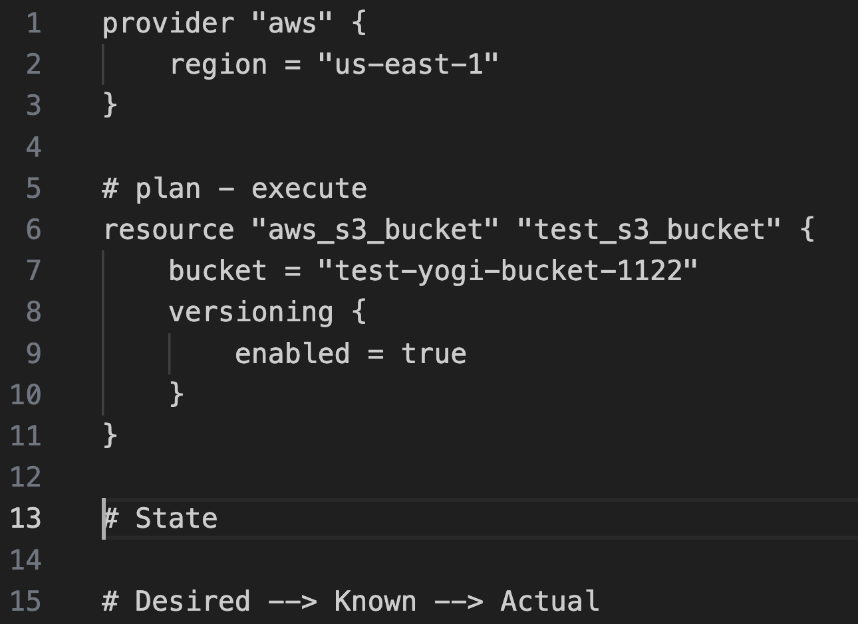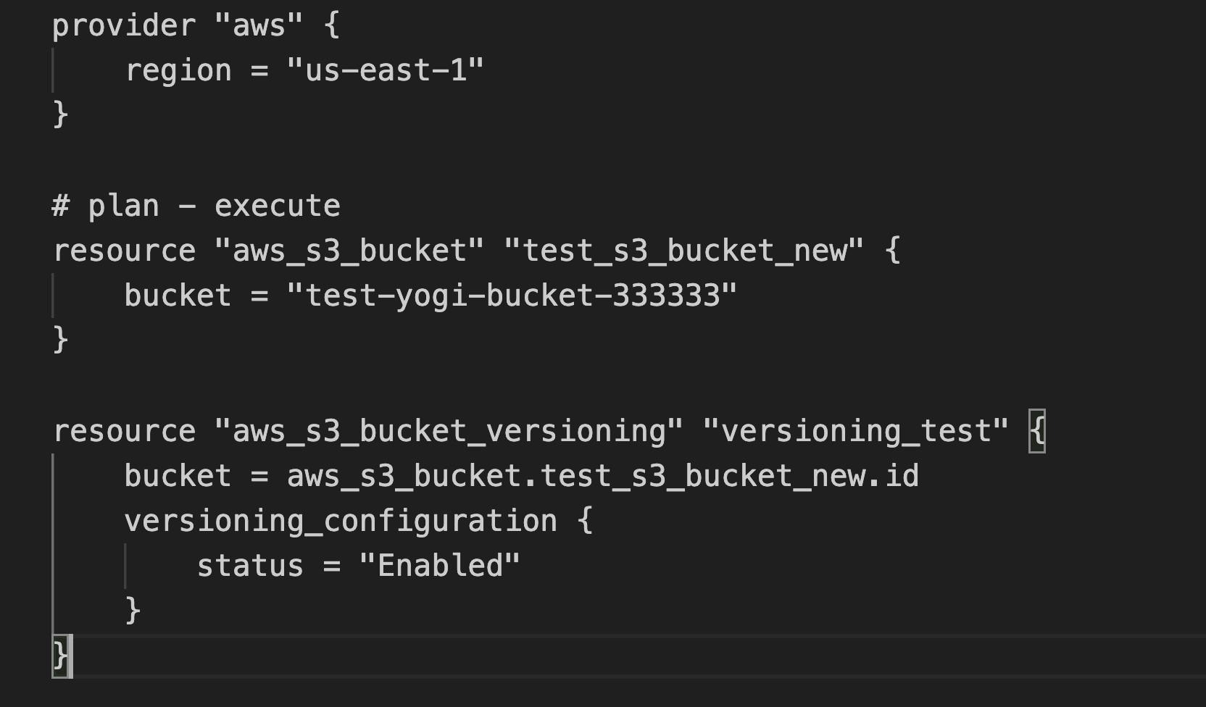
- Terraform Console
The Terraform console is an interpreter that you can use to evaluate Terraform expressions and explore your Terraform project's state. The console helps you develop and debug your configuration, especially when working with complex state data and Terraform expressions.
$ terraform console
> aws_s3_bucket.test_s3_bucket
> aws_s3_bucket.test_s3_bucket.versioning
> aws_s3_bucket.test_s3_bucket.versioning[0].enabled
> exit
- How to create IAM user using Terraform
- Login to AWS portal and check the existing user
- Now write the script in Terraform to create a user in AWS
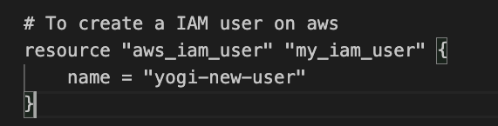
- Go on command prompt → execute terraform script → this will create a user on AWS
- If I will change the username in script and re-execute script → the user will rename
- If I want to create a new user then for now I have to delete .tfstate file → then re-execute the script with new user name
- Now create a new folder and create a main.tf file in it → terraform init → and create other users from it
% terraform plan -out iam.tfplan (This command is used to see the plan and to save that plan as output)
% terraform apply "iam.tfplan" (This command is used to execute a saved plan)
.tfstate → This file is for known state and it contains the last execution
.tfstate.backup → This is the backup file of .tfstate or a file before execution
- When I write a Terraform script and I just want to execute the script only for one resource then I can define the resource as target in command:
$ terraform apply -target=aws_iam_user.<user name>
- We can create multiple .tf files inside a single folder and when we execute → $ terraform apply command → It includes all the files arguments and implements them in one short.
- Gitignore in Terraform
Generally we ignore to push .tfstate files in repos for Teffaform projects and for this we use .gitignore file to add terraform files and directories.

.tf
.tfstate
.tfstatebackup

- Rename the .tfstate files and then execute the terraform script.
- $ terraform destroy (To delete all the resources present in .tfstate file)
- $ terraform validate (To check the script for any syntax error)
- $ terraform fmt (command used to set the formatting automatically in .tf file)
- $ terraform show (It shows the present state of .tfstate file)
https://developer.hashicorp.com/terraform/cli/commands/plan

- $ terraform apply -auto-approve
- Variable declaration in Terraform:
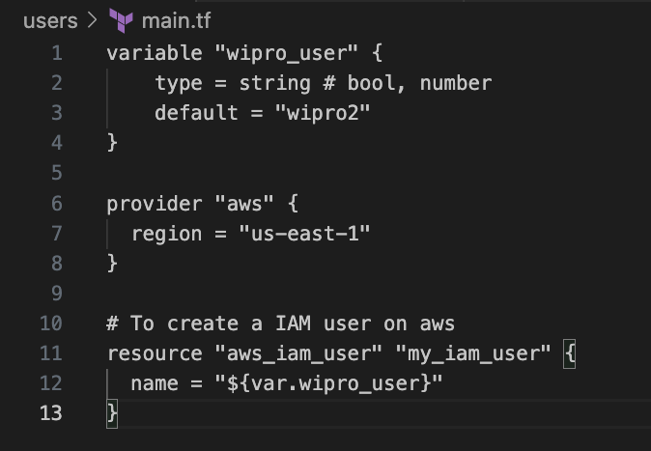
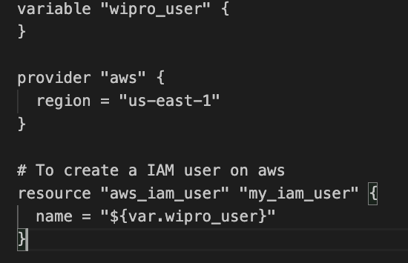

- 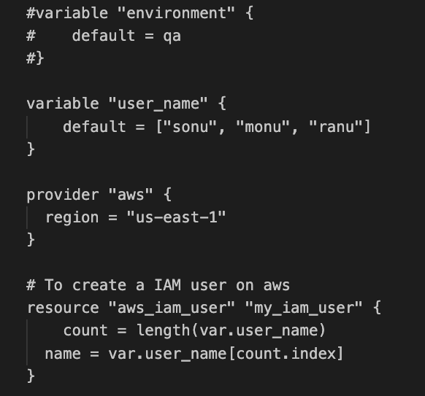
- How to create EC2 instance using Terraform:
Below is the terraform script to create EC2 instance
____________________________________________________
- variable "aws_key_pair" {
- default = "/Users/yogeshgupta/Downloads/terraform-key.pem"
- }

- provider "aws" {
- region = "us-east-1"
- //version = "~> 2.46" (No longer necessary)
- }

- resource "aws_default_vpc" "default" {

- }

- resource "aws_security_group" "http_server_sg" {
- name = "http_server_sg"
- //vpc_id = "vpc-c49ff1be"
- vpc_id = aws_default_vpc.default.id

- ingress {
- from_port = 80
- to_port = 80
- protocol = "tcp"
- cidr_blocks = ["0.0.0.0/0"]
- }

- ingress {
- from_port = 22
- to_port = 22
- protocol = "tcp"
- cidr_blocks = ["0.0.0.0/0"]
- }

- egress {
- from_port = 0
- to_port = 0
- protocol = -1
- cidr_blocks = ["0.0.0.0/0"]
- }

- tags = {
- name = "http_server_sg"
- }
- }

- resource "aws_instance" "http_server" {
- ami = "ami-053b0d53c279acc90"
- key_name = "terraform-key"
- instance_type = "t2.micro"
- vpc_security_group_ids = [aws_security_group.http_server_sg.id]
- subnet_id = "subnet-0444f13703bb89da4"

- connection {
- type = "ssh"
- host = self.public_ip
- user = "ubuntu"
- private_key = file(var.aws_key_pair)
- }

- provisioner "remote-exec" {
- inline = [
- "sudo apt-get update -y",
- "sudo apt-get install apache2 -y",
- "sudo echo Welcome to this test Terraform EC2 website at ${self.public_dns} | sudo tee /var/www/html/index.html"
- ]
- }
- }

____________________________________________________

- export TF_VAR_iam_user_name_prefix = FROM_ENV_VARIABLE_IAM_PREFIX
- export TF_VAR_iam_user_name_prefix=FROM_ENV_VARIABLE_IAM_PREFIX
- terraform plan -refresh=false -var="iam_user_name_prefix=VALUE_FROM_COMMAND_LINE"
- terraform apply -target=aws_default_vpc.default
- terraform apply -target=data.aws_subnet_ids.default_subnets
- terraform apply -target=data.aws_ami_ids.aws_linux_2_latest_ids
- terraform apply -target=data.aws_ami.aws_linux_2_latest
- terraform workspace show
- terraform workspace new prod-env
- terraform workspace select default
- terraform workspace list
- terraform workspace select prod-env
—----------
—----------

—----------

EC2_Instance_Script

variable "aws_key_pair" {
default = "/Users/ygupta/Documents/Terraform-Dec/terraform-key.pem"
}

provider "aws" {
region = "us-east-1"
}

resource "aws_default_vpc" "default" {

}

resource "aws_security_group" "http_server_sg" {
name = "http_server_sg"
vpc_id = aws_default_vpc.default.id

ingress {
from_port = 80
to_port = 80
protocol = "tcp"
cidr_blocks = ["0.0.0.0/0"]
}

ingress {
from_port = 22
to_port = 22
protocol = "tcp"
cidr_blocks = ["0.0.0.0/0"]
}

egress {
from_port = 0
to_port = 0
protocol = -1
cidr_blocks = ["0.0.0.0/0"]
}

tags = {
name = "http_server_sg"
}
}

resource "aws_instance" "http_server" {
ami = "ami-0fc5d935ebf8bc3bc"
key_name = "terraform-key"
instance_type = "t2.micro"
vpc_security_group_ids = [aws_security_group.http_server_sg.id]
subnet_id = "subnet-0ee35973e9f92ade3"

connection {
type = "ssh"
host = self.public_ip
user = "ubuntu"
private_key = file(var.aws_key_pair)
}

provisioner "remote-exec" {
inline = [
"sudo apt-get update -y",
"sudo apt-get install apache2 -y",
"sudo echo Welcome to this test Terraform EC2 website at ${self.public_dns} | sudo tee /var/www/html/index.html"
]
}
}

